VALORIZATION AND EVALUATION OF SAND TYPE ON FRESH AND HARDENED PROPERTIES OF SELF-COMPACTING REPAIR MORTAR USING LIMESTONE POWDER AS FILLER
Salhi Aimad*¹, Kriker Abdelouahed², Tioua Tahar³ and Dehane Sara⁴
^{1, 4}Department of Hydraulic and Civil Engineering, Faculty of Technology, University of Ghardaia, Algeria
^{1, 2, 3, 4}Laboratory of Exploitation and Valorisation of natural Ressources in Arid Arears (E.V.R.N.Z.A), University of Kasdi Merbah, Ouargla, Algeria.
¹http://orcid.org/0009-0009-5896-1166, ²http://orcid.org/0009-0003-6297-2374
³http://orcid.org/0000-0001-5346-4907, ⁴http://orcid.org/0009-0002-4482-2092

Email:*salhi.aimad@univ-ghardaia.edu.dz, a_kriker@yahoo.fr,tahar.tioua@centre-univ-mila.dz, sarra.dhn@gmail.com
ARTICLE INFO |  |  | ABSTRACT
Article History  Received: January 25, 2026  Reviewed: March 26, 2026  Accepted: April 26, 2026  Published: May 29, 2026 |  |  | The objective of this work is to study the effect of sand type on the physical and mechanical behavior and durability of self-compacting repair mortar (SCM). Six types of sand were used in this study, crushed limestone sand (CS), silica roller gravel sand (GRCS), dune sand (DS), mixed sand (70% DS + 30% CS) and normalized sand (NS). The three-point compression and tensile tests were carried out for the periods: 2 days, 7 days, 28 days with absorption and 90 days.The results showed that the rheological properties of the fresh mortar which were carried out using the flow and diffusion tests are largely in line with the recommendations of EFNARC, while in the hardened state, the samples consisting of (CS) showed high compressive strength in 28 days, reaching an increase of 21.79% over the control sample. The three-point tensile strength showed superior results over the control by 26.61%. As for the rest of the samples, they showed relatively acceptable results, although they were lower than the control results. The durability test also confirmed the results obtained in the three-point compression and tensile tests, where the higher the three-point compression and tensile results, the lower the porosity.
Keywords:
Valorization,
Sand,
Self-compacting repair mortar,
Limestone filler,
Durability.

 | Copyright ©2026 by authors and Galileo Institute of Technology and Education of the Amazon (ITEGAM). This work is licensed under the Creative Commons Attribution International License (CC BY 4.0).

I. INTRODUCTION
Aggregates and in particular sand have been the basis of the construction industry since Roman times and up to the present day. Several sources indicated that the amount of sand extracted in the world annually exceeds 15 billion tons [1], [2], making it the second most used resource after water [3]. Extracting sand in such large quantities as a result of significant demographic growth poses many environmental problems such as the decline in groundwater levels, the destruction of vegetation in rivers, and soil erosion [4-7], and it also leads to the depletion of non- renewable resources in some countries. Algeria is among the countries that have experienced a great shortage of natural sand such as Morocco, Turkey [8], Spain, Argentina [9], India [10] and China [11]. However, Algeria has very abundant local alternatives, and their development is an excellent opportunity to considerably reduce the cost of concrete materials, reduce environmental pollution and preserve natural resources. Deserts cover approximately one-third of the Earth's land area, with the desert in Algeria comprising about 90% of the total area. Their most distinctive feature is the abundance of sand dunes, coupled with a severe shortage of alluvial sand needed for concrete production. Transporting alluvial sand over long distances significantly increases the cost of this material. Against this background, dune sand could have a definite economic advantage. Nevertheless, the technical side suggests that this material has anomalies requiring treatment or transformations, and cannot be used in its raw state. From these anomalies, arise the desire to find a solution for the integration of this material in the production of concrete. Several studies [12-15], carried out on dune sands have shown that this material has a very fine grain size, resulting in a significant shrinkage of concrete. Crushed calcareous sand, which is present in large quantities in gravel crushing and screening stations, has limited use, as only a small percentage is used to complete road foundation layers and sub-road foundations, while the rest goes to landfills.
This very low demand is due to the high proportion of fine particles (i.e., particles of size ˂ 80 µm). Several authors [9], [16-18] have proven that the properties of conventional concrete with crushed sand can be negatively affected if the dust percentage increases to a certain extent. However, this dust ratio can be useful in some applications such as the production of self-compacting mortar (SCM) and self-compacting concrete (SCC). Despite its recent appearance, SCM and SCC has managed to achieve wide dissemination thanks to its competitive advantages over conventional mortar [19-23]. In addition to its economic advantages, it offers environmental solutions to several types of waste or by-products, which can now be used as mineral additives, whereas their fate was previously either landfills or burial sites. In this context, several types of waste or by-products have been studied such as the case of plastic waste, crushed brick, glass waste, [24-26]. This waste is used as a replacement for alluvial sand in SCM. All of this research has yielded very promising results. The main objective of this research is to study the effect of different sands on the mechanical and fresh characteristics of SCM. (Crushed calcareous sand, crushed rolled gravel sand (silica) and dune sand). The various sands used here are originally either an industrial by-product that is sent to landfills, or is present in abundance. Tests on SCM in the fresh state, hardened state and sorptivity coefficients are tested at different ages. According to previous studies, most researchers have focused on concrete or mortar containing crushed limestone sand or dune sand as an alternative to alluvial sand, limiting their research to liquid and solid state experiments [27-30]. The effect of these alternatives on the performance of self-compacting mortar, particularly its impact on durability, has not been thoroughly investigated. Therefore, this study intends to fill this research gap by investigating the feasibility of incorporating these alternatives and their effect on the durability of self-compacting repair mortar.
II. MATERIALS AND METHODS
II.1 MATERIALS
II.1.1 Cement
Cementitious material used to produce SCM were ordinary Portland cement type CEM II /A-L 42,5 N complying with the Algerian standard NA 442 [31]. It had a specific gravity of 3.07 and the Blain surface was equal to 4465 cm2/g. The chemical compositions of the cement are given in Table 1.
Table 1: Chemical compositions of cement.
Compounds | SiO2 | Al2O3 | Fe2O3 | CaO | MgO | K2O | Na2O | SO3 | Cl- | P.A.F | Free CaO | R.I
% | 18,47 | 4,63 | 3,34 | 61,08 | 1,16 | 0,71 | 0,4 | 2,64 | 0,017 | 6,69 | 0,87 | 2,15
Source: Authors, (2026).
II.1.2 Sands
For the purposes of this study, six different sands were used:
• The first is river sand with a continuous particle size distribution ranging from 5mm to 0.08mm, but the fraction below 0.16mm remains very small Figure 1(a).
• The second is a crushed limestone fine sand designated by CS (Crushed sand) Figure 1(b) collected from Ouargla region, also has a continuous particle size distribution with a maximum grain diameter of about 3 mm, but the proportion of grains smaller than 0.08 mm is less than 30% Figure 2.
• The third is crushed rolled gravel sand (CRGS) Figure1(c) resulting from crushing and sieving, which is a natural gravel of a siliceous nature available locally brought from Hassi Sayeh (around the city of Ouargla).
• The fourth is dune sand (DS) Figure 1(d) collected from Sidi khouiled in the Ouargla area and has a maximum grain diameter of about 0.63 mm; the proportion of grains less than 0.08 mm is less than 5% characterized of its abundance in nature (Sahara) with almost zero extraction cost.
• The fifth is a corrected sand (CDS) of crushed rolled gravel-dune Figure 1(e) prepared by correcting the fine part of dune sand by a part of sand (CRGS) according to a mass ratio (CRGS / DS) = 1,25.
• The sixth is a standardized sand (SN) Fig.1(f) complying with the requirements of standard EN 196-1 [32], of natural origin, siliceous in particular in its finest fractions. It is packaged in polyethylene bags containing 1350 ± 5 g.
The physical properties and the particle size analysis curves of these sands are shown in Table 2 and Figure 1, respectively. Figure 3 shows the X-ray diffractogram for our natural sand. It can be seen that the sand used is silico-calcareous due to the existence of two intense and dominantly peaks, the peaks of quartz and calcite.
Table 2: Physical characteristics of sand.
Sand | Apparent density (kg/m3) | Specific density (kg/m3) | Fineness modulus | Absorption | Sand equivalent (%)
AS | 1545 | 2637 | 1,99 | 0,108 | 49
CS | 1487 | 2649 | 2,14 | 4984 | 40
CRGS | 1384 | 2654 | 2,48 | 0,304 | 96
DS | 1488 | 2658 | 0,95 | 0,271 | 81
DS-CRGS | 1614 | 2658 | 1,57 | 0,801 | 95
S | 1570 | 2658 | 1,93 | 0,096 | 95
Source: Authors, (2026).
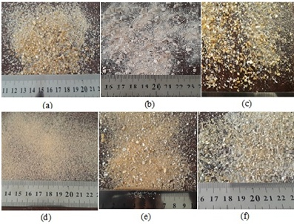
Figure 1: Photo of the Particles of (a) River Sand (RS), (b) Crushed Sand (CS), (c) Crushed Round Gravel Sand (CRGS),
(d) Dune sand (DS), (e) Corrected dunes sand (CDS), (f) Normalized sand (NS).
Source: Authors, (2026).
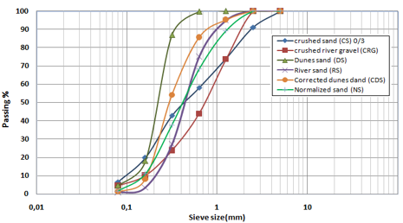
Figure 2: Particle size distribution of the various sands used.
Source: Authors, (2026).
II.1.3 Limestone filler
The limestone filler is a waste of calcareous rock crushing, coming from quarries of the production of aggregates, it had a specific gravity of 2.7 and the Blain surface was equal to 442 m²/kg.
II.1.4 Super plasticizer
To achieve the desired self-compacting properties, an admixture named viscocrete tempo12, which is a modified acrylic copolymer based superplasticizer, with a solid content of 36% and 1.09 kg/l density, was employed.
II.2 METHODS
II.2.1 Mixture Proportion and Mixture procedure
Six distinct mortar mixes were produced with different types of sand. Table 3 shows the details of the SCM mixtures.
Table 3: Mixture proportions of mortars.
Mixes | water / binder | Cement (kg) | Limestone filler (kg) | Sand (kg) | Water (kg) | Super plasticizer (kg)
SA | 0,40 | 550 | 100 | 1300 | 260 | 14,3
SC | 0,40 | 550 | 100 | 1300 | 260 | 15,4
CRGS | 0,40 | 550 | 100 | 1300 | 260 | 17,6
DS | 0,60 | 550 | 100 | 1300 | 390 | 6,6
CDS | 0,40 | 550 | 100 | 1300 | 260 | 13,2
SN | 0,40 | 550 | 100 | 1300 | 260 | 9,9
Source: Authors, (2026).
All SCM mixtures have been prepared in an identical mixing process to ensure similarity and uniformity. The mixing sequence consisted of homogenizing the binder and the sands for one minute using a standard mixer. Then two-thirds of the mix water was added and mixed for another minute. After that, the remaining water (one third) and super plasticizer were added and mixing was continued for three minutes. For each type of mortar, a set of twelve prismatic specimens (40 mm x 40 mm x 160 mm) was made. Samples were demolded after 24 h and cured at 95 ± 5% relative humidity and 20 ± 2°C temperature until test date.
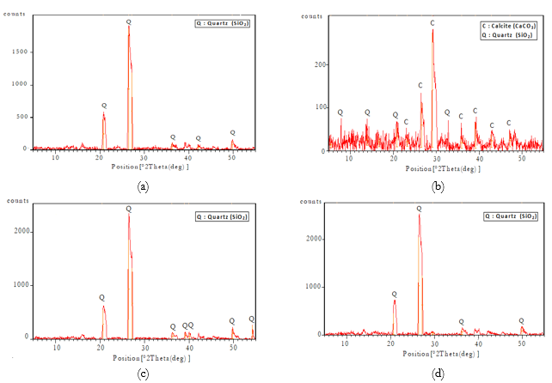
Figure 3: XRD diffractogram of natural sands: (a) River Sand (RS), (b) Crushed Sand (CS),
(c) Crushed Round Gravel Sand (CRGS), (d) Dunes sand (DS).
Source: Authors, (2026).
III.TESTING PROCEDURES
III.1 WORKABILITY
To study the behavior of fresh self-compacting mortar, slump flow and V-funnel flow tests Figure 4 were performedbased on EFNARC recommendations [33].
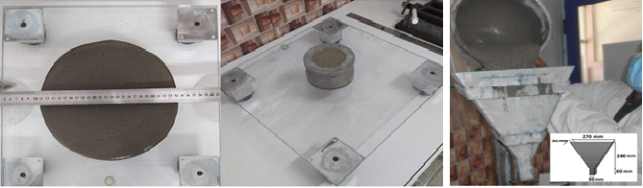
(a) (b)
Figure 4: Fresh self-compacting mortar test: (a) slump flow test and (b) V-funnel test.
Source: Authors, (2026).
III.2 FLEXURAL AND COMPRESSIVE STRENGTH
For the mechanical tests, three-point bending tests were carried out at 3, 7, 28 and 90 days on prismatic samples(40 × 40 × 160 mm³) according to ASTM C348 [34]. After breaking the three samples during the bending tests, the two parts (40 x 40 x 80 mm³) of each prism were subjected to a compressive strength test according to ASTM C349 [35].
III.3 WATER ABSORPTION
Water absorption was performed based on ASTM C1585-04 [36]. Mortar samples obtained by sawing prisms of dimensions 40 x 40 x 80 mm3 Figure 5. The samples hardened for 28 days were used for the evaluation of the sorptivity coefficient k
$k=Q/{A\sqrt{t}}$ (1)
Where Q is the accumulated absorbed water in cm3, A is the exposed cross section of the sample in cm2, t is the time in min and k is the sorptivity coefficient in cm / min0.5. k is calculated using a linear change between the cumulative water absorption (Q) and the square root of time (t).
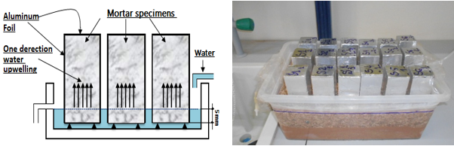

Figure 5: Schematic and photographs of water absorption test.
Source: Authors, (2026).
IV. RESULTS AND DISCUSSIONS
IV.1 FRESH PROPERTIES
Slump flow diameter and V-funnel flow time values are presented in Figures 6 and 7. It is obvious that SCM mixtures ensured EFNARC recommendation for relative slump and relative funnel speed. As shown in Figure 6, the highest slump flow value of 260 mm was obtained by DS without any segregation, while the lowest value of 242 mm was recorded for CS. It can be concluded from these results that a decrease in the fluidity of mortars with CS, GRCS and CDS sand was observed. This decrease in fluidity is due to the angular or irregular shape of the granular skeleton of its sands which hinders (or slows down) the flow of the mortars (see Figure 7). Many studies have been conducted on the effect of irregular shapes of coarse aggregates on the rheology of self-compacting concrete [3], [37]. On the other hand, RS, DS and NS sands, which have a spherical shape, promote the flow of mortars. Similar results were reported by Bederina [8].

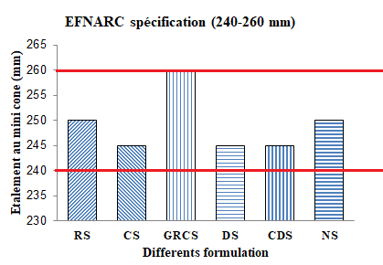
Figure 6: Results of fresh SCMs mixes tests: Slump flow diameter.
Source: Authors, (2026).
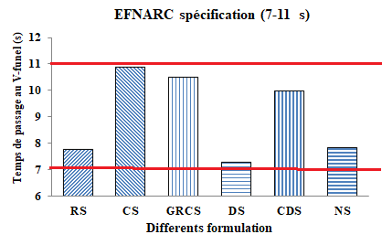
Figure 7: Results of fresh SCMs mixes tests: V-funnel flow time.
Source: Authors, (2026).

IV.2 COMPRESSIVE STRENGTH
Results of the compressive strength tests of the SCM composed of different types of sand are given in Figure 8. The compressive strength of the different mixtures is in the ranges 8.38 - 25.46; 9.81 - 29.06; 18.33 - 37.22 and 19.83 - 40.20 MPa, at ages of 2, 7, 28 and 90 days, respectively. The CS mixture showed an increase of 83.03%, 60.91%, 21.79% and 22.63% at the ages of 2, 7, 28 and 90 days, respectively, over that of the control RS and NS. The increase in the compressive strength can be explained by the angularity of the CS grains on the one hand [17] and by the pore filling effect of the powder of limestone which contains the CS on the other.
The latter also provided a suitable core for hydration and thus catalyze the hydration. This result is in agreement with the results of other authors [19], [38]. While the remaining mixtures, namely CGRS, DS, CDS showeda decrease in resistance at different ages compared to AS and NS. The mixture of the CGRS crushed rolled gravel sand recorded a decrease of 7.40%, 4.5%, 6.80% and 10.20% at the ages of 2, 7, 28 and 90 days, respectively. The decrease in the compressive strength of mortar samples with washed crushed rolled gravel sand (CGRS) can also be attributed to a significant reduction in the proportion of fine material in the mortar mixes caused by sand washing. Indeed, the fine material plays the role of filling the pores and its loss negatively affects the resistance.
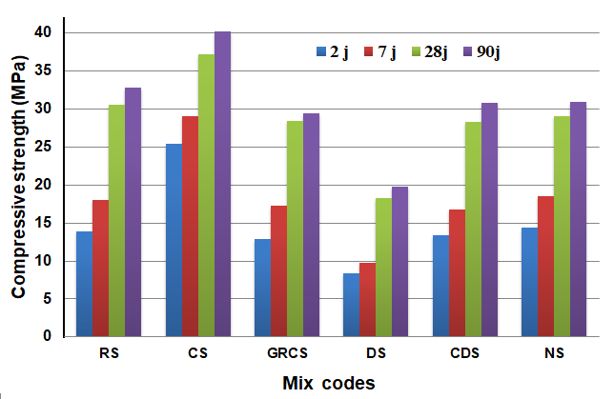
Figure 8: The compressive strength of the different mixtures.
Source: Authors, (2026).
While the remaining mixtures, namely CGRS, DS, CDS showeda decrease in resistance at different ages compared to AS and NS. The mixture of the CGRS washed crushed rolled gravel sand recorded a decrease of 7.40%, 4.5%, 6.80% and 10.20% at the ages of 2, 7, 28 and 90 days, respectively. The decrease in the compressive strength of mortar samples with crushed rolled gravel sand (CGRS) can also be attributed to a significant reduction in the proportion of fine material in the mortar mixes caused by sand washing. Indeed, the fine material plays the role of filling the pores and its loss negatively affects the resistance. The DS mixture recorded a decrease of 39.70%, 45.70%, 40.00% and 39.50% at the ages of 2, 7, 28 and 90 days, respectively. This significant decrease in resistance is generally due to poorly graded dune sand (a tight granulometry) where the refusal is zero until a sieve of 0.63 mm. Another reason for the decrease in the resistance to compression could be linked to the increased specific surface area of ​​fine aggregates requiring more grout to coat the surface of the aggregates. These results are in agreement with the results of other authors [15]. And finally, the mixture of the CDS-corrected dune sand recorded a decrease of 3.70%, 7.20%, 7.30% and 6.10% at 2, 7, 28 and 90 days, respectively, compared to that of AS. In addition, it showed an increase over uncorrected dune sand of 37.50%, 41.40%, 35.30% and 35.60% at ages of 2, 7, 28 and 90 days, respectively. This increase shows the beneficial effect of correction, and that the corrected dune sand can be used as an alternative to AS sand.
IV.3 FLEXURAL STRENGTH
Figure 9 shows the variations in flexural strength of the different mortars studied as a function of time. It should be noted that the remarks made on the flexural strength are almost similar to those noted on the compressive strength. Flexural strength values ​​vary between 3.52 and 12.09 MPa, with the lowest flexural strength for DS at 2 days curing and the highest for CS after 90 days curing. The CS mixture exhibited an increase of 22.16%, 22.08%, 26.62% and 26.86% at 2, 7,28 and 90 days, respectively, compared to the RS control. But for the remaining mixtures, namely CGRS, DS and CDS, they recorded a decrease in resistance at all ages compared to the control where the DS mixture recorded the weakest results with a decrease of 46.30%, 40 ,10%, 33.30% and 27.80% at 2, 7, 28 and 90 days, respectively, compared to the control RS.
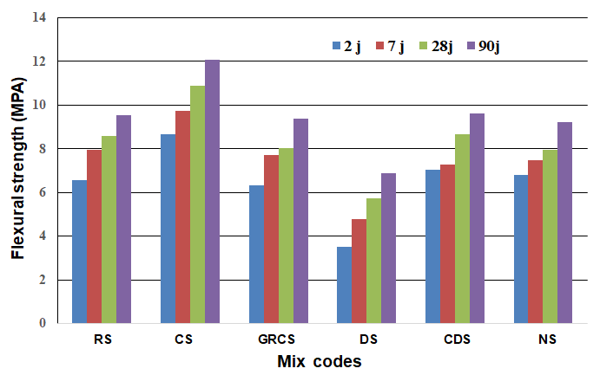
Figure 9: The compressive strength of the different mixtures.
Source: Authors, (2026).
The increase in flexural strength in the CS mixture is related to the greater amount of powdery materials and the blocking effect due to the angular shape of the aggregates. These results are also supported by Abu Seif [36]. Furthermore, the mineralogical source has a great effect on the resistance, where mixtures with limestone aggregates (CS) have better resistances than those with silica sands (CGRS, DS, CDS). These results are in agreement with the results of Bederina [8].
IV.4 CORRELATION BETWEEN COMPRESSIVE STRENGTH AND FLEXURAL STRENGTH
The correlation between flexural strength and compressive strength after 3,7,28 and 90 days of curing is illustrated in Figure 10. From the latter, it can be said that there are strong correlations between the compressive strength and the flexural tensile strength values of the SCMs produced from the different sands. The trend line and R-squared (R2) values confirm these strong correlations between compressive strength and flexural tensile strength.
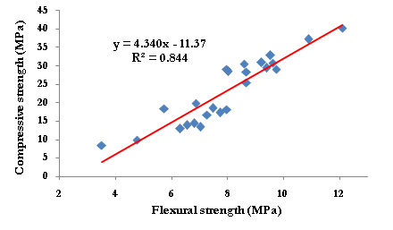
Figure 10: Relation between the compressive and flexural strength of SCMs.
Source: Authors, (2026).
IV.5 WATER ABSORPTION
The water absorption test allows to characterize the porosity, which communicates with the external surface of the mortar; it is considered as an indicator of durability. The results of the water absorption test for different designs of SCMs mixtures composed of different types of sand at 28 days of age are shown in Figure 11. The water uptake of the samples during the first 24 hours was matched using linear regression, the sorptivity of the samples up to 24 hours was determined using the slopes of the equations.
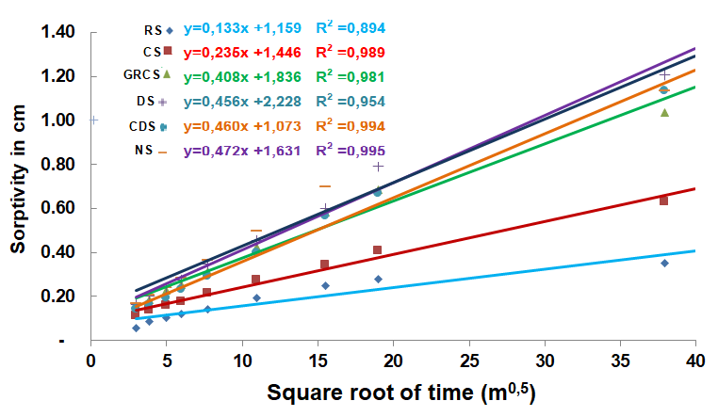
Figure 11: Water absorption of SCMs aged 28 days.
Source: Authors, (2026).
It can be observed that the cumulative volume of water absorbed by the SCM samples increases by increment of time. At the end of the exposure time, we can see that the mixture with CS displayed a slight increase in sorptivity. value of 0.63 x 103 cm / m 0.5 for the age of 28 days, compared to the sample control AS whose sorptivity was 0.35 x 103 cm / m 0.5, while the mixture with DS showed the highest sorptivity value of 1.21 x 103 cm compared to the remaining mixtures, namely NS, CDS and GRCS which have sorptivity values ​​of 1.13 x 103 cm, 1.13 x 103 cm and 1.04 x 103 cm, respectively. It can be concluded that the control mixture gave a relatively low sorptivity due to the dense and hard structure of the river sand (AS), then the closest result to the control mixture AS is the CS mixture. This result is consistent with the literature advocating the pore-filling effect of fine fillers [39], [40]. In contrast, the highest sorptivity value was observed in the mixture which contains DS at 100% replacement rate. Similar results were observed in other researches.

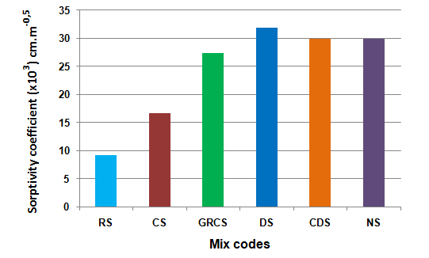
Figure 12: Sorptivity values ​​of SCMs after 28 days of curing.
Source: Authors, (2026).
Figure 12 presents the sorptivity coefficients of the SCM mixtures at 28 days. Figure 12 highlights that RS and CS have the lowest sorptivity coefficients ​​of 9.22 x 10⁻³ cm. min^{-0.5} and 16.63 x 10⁻³ cm. min^{-0.5}, respectively, compared to GRCS, DS, CDS and NS mixtures which recorded sorptivity coefficients of 27.34 x 10⁻³ cm. min^{-0.5}, 31.79 x 10⁻³ cm. min^{-0.5}, 29.87 x 10⁻³cm. min^{-0.5} and 29.87 x 10⁻³ cm. min^{-0.5}, respectively.
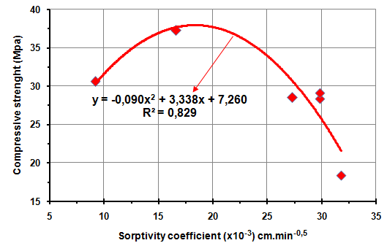
Figure 13: Correlation between the compressive strength and sorptivity coefficient at 28 days.
Source: Authors, (2026).
The values ​​of the sorptivity coefficients of all the mixtures at the age of 28 days show the same trend as the compressive strength with the lowest for the control mixture SCM and the highest for the DS. Figure 13 shows the relationship between the compressive strength and the sorptivity coefficient of the different mixtures.
V. CONCLUSIONS
The following conclusions can be drawn from the study:
- All the mixes show satisfactory self-compacting properties in the fresh state with a constant water/cement ratio except for the DS mix which requires a higher w/c, all fulfilling the recommendations of the EFNARC related to passage capacity and flow time.
- Compressive and tensile strengths of all SCM samples increased as curing age increased from 2 days to 90 days. mixtures containing CS had higher strengths than all other mixtures. DS correction (DSC) resulted in increased compressive and tensile strength at all ages compared to DS mixture alone.
- CRGS, DS and CDS mixes of SCMs having high sorptivity values generally exhibits low compressive strength as sorptivity results are compared to compressive strength of the samples cured in water at the age of 28 days.
- Crushed sand with semi-high fines content can be successfully used in the production of SCM, achieving the dual purpose of conserving natural resources and protecting the environment at the same time.
VI. AUTHOR’S CONTRIBUTION
Conceptualization: Aimad Salhi and Tioua Tahar.
Methodology: Aimad Salhi, Abdelouahed Kriker and Dehane Sara.
Investigation: Aimad Salhi, Abdelouahed Kriker, Dehane Sara and Tioua Tahar.
Discussion of results: Aimad Salhi, Dehane Sara and Tioua Tahar.
Writing – Original Draft: Aimad Salhi.
Writing – Review and Editing: Dehane Sara and Tioua Tahar.
Resources: Aimad Salhi and Tioua Tahar.
Supervision: Aimad Salhi and Abdelouahed Kriker.
Approval of the final text: Aimad Salhi and Abdelouahed Kriker.

VII. REFERENCES
[1] UNEP 2019. United Nations Environment Programme.

[2] Cao et al Y. Cao , Y. Wang , Z. Zhang , Y. Ma , H. Wang ( 2021 ) :Recent progress of utilization of activated kaolinitic clay in cementitious construction materials, Journal of Composites Part B, Article 108636

[3] Wesley, D., & Puffer, S. (2019) The End of Sand: Confronting One of the Greatest Environmental Challenges of the New Millennium. In Reusable and Sustainable Building Materials in Modern Architecture (pp. 1-27) IGI Global.

[4] A. Srivastava, S.K Singh. (2020) Utilization of alternative sand for preparation of sustainable mortar: a review, J. Clean. Prod., 253, Article 119706

[5] Y. Jiang, B. Li, S. Liu, et al. (2022) Role of recycled concrete powder as sand replacement in the properties of cement mortar, J. Clean. Prod., 371, Article 133424

[6] Mani, M., Bouali, M.F., Kriker, A., Hima, A. (2021). Experimental characterization of a new sustainable sand concrete in an aggressive environment, Frattura Ed IntegritaStrutturale, 15(55). DOI: 10.3221/IGF-ESIS.55.04.

[7] Belferrag, A., Kriker, A., Abboudi, S., Bi, S.T. (2016). Effect of granulometric correction of dune sand and pneumatic waste metal fibers on shrinkage of concrete in arid climates, J Clean Prod, 112. DOI: 10.1016/j.jclepro.2015.11.007.

[8] Bederina, M., Makhloufi, Z., Bounoua, A., Bouziani, T., Quéneudec, M. (2013). Effect of partial and total replacement of siliceous river sand with limestone crushed sand on the durability of mortars exposed to chemical solutions, Constr Build Mater, 47. DOI: 10.1016/j.conbuildmat.2013.05.037.
[9] B. Menadi, S. Kenai, J. Khatib, A. Ait-Mokhtar (2009): Strength and durability of concrete incorporating crushed limestone sand, Constr. and Build. Materials 23.

[10] Jadhav, P.A., Kulkarni, D.K. (2012). An experimental investigation on the properties of concrete containing manufactured sand, International Journal of Advanced Engineering Technology E-ISSN, 3(2).

[11] Hen, W., Yang, Z., Cao, L., Cao, L., Liu, Y., Yang, H., Lu, Z., Bai, J. (2016). Characterization of manufactured sand: Particle shape, surface texture and behavior in concrete, Constr Build Mater, 114. DOI: 10.1016/j.conbuildmat.2016.03.201. الصين

[12] Djoual Belkacem ,Mitiche-Kettab Ratiba ,Zaitri Rebih (2025) Amélioration de la durabilité du béton de sable autoplaçant grâce à l'utilisation d'additifs minéraux, World Journal of Engineering, 22 (6), DOI: 10.1108/WJE-03-2024-0126.

[13] Belferrag, A., Kriker, A., Khenfer, M.E. (2013). Improvement of the compressive strength of mortar in the arid climates by valorization of dune sand and pneumatic waste metal fibers, Constr Build Mater, 40. DOI: 10.1016/j.conbuildmat.2012.11.079.

[14] Guettala, S., Mezghiche, B. (2011). Compressive strength and hydration with age of cement pastes containing dune sand powder, Constr Build Mater, 25(3). DOI: 10.1016/j.conbuildmat.2010.09.026.

[15] Abu Seif, E.S.S., Sonbul, A.R., Hakami, B.A.H., El-Sawy, E.K. (2016). Experimental study on the utilization of dune sands as a construction material in the area between Jeddah and Mecca, Western Saudi Arabia, Bulletin of Engineering Geology and the Environment, 75(3). DOI: 10.1007/s10064-016-0855-9.

[16] Djedid, T., Mani, M., Guettala, A., Hima, A. (2021). Analysis of workability, mechanical strength and durability by the FT-IR method of concrete based on silica-limestone sand preserved in aggressive environments, Frattura Ed Integrita Strutturale, 15(59). DOI: 10.3221/IGF-ESIS.59.37.

[17] Benabed, B., Azzouz, L., Kadri, E.H., Kenai, S., Belaidi, A.S.E. (2014). Effect of fine aggregate replacement with desert dune sand on fresh properties and strength of self-compacting mortars, J Adhes Sci Technol, 28(21). DOI: 10.1080/01694243.2014.950625.

[18] Esra Türk, Mehmet Karataş, Murat Dener (2022). Propriétés rhéologiques, mécaniques et de durabilité des mortiers autoplaçants contenant de la poudre de basalte et de la fumée de silice, Constr Build Mater, 356. DOI: 10.1016/j.conbuildmat.2022.129229.

[19] Nanthagopalan, P., Santhanam, M. (2011). Fresh and hardened properties of self-compacting concrete produced with manufactured sand, Cem Concr Compos, 33(3). DOI: 10.1016/j.cemconcomp.2010.11.005.

[20] Ferrara, L., Park, Y.D., Shah, S.P. (2007). A method for mix-design of fiber-reinforced self-compacting concrete, CemConcr Res, 37(6). DOI: 10.1016/j.cemconres.2007.03.014.

[21] Okumara, H., Ouchi, M. (1999). Self-compacting concrete development, present use and future., 1st International RILEM Symposium on Self-Compacting Concrete.

[22] Zhao, Z., Grellier, A., el Karim Bouarroudj, M., Michel, F., Bulteel, D., Courard, L. (2021). Substitution of limestone filler by waste brick powder in self-compacting mortars: Properties and durability, Journal of Building Engineering, 43. DOI: 10.1016/j.jobe.2021.102898

[23] Sharifi, Y., Houshiar, M., Aghebati, B. (2013). Recycled glass replacement as fine aggregate in self-compacting concrete, Frontiers of Structural and Civil Engineering, 7(4), pp. 419–428.

[24] Aboutaleb, D., Safi, B., Chahour, K., Belaid, A. (2017). Use of refractory bricks as sand replacement in self-compacting mortar, Cogent Eng, 4(1). DOI: 10.1080/23311916.2017.1360235.

[25] Safi, B., Saidi, M., Aboutaleb, D., Maallem, M. (2013). The use of plastic waste as fine aggregate in the self-compacting mortars: Effect on physical and mechanical properties, Constr Build Mater, 43. DOI: 10.1016/j.conbuildmat.2013.02.049.

[26] Mousavi, S.R., Afshoon, I., Bayatpour, M.A., Davarpanah T.Q., A., Miri, M. (2021). Effect of waste glass and curing aging on fracture toughness of self-compacting mortars using ENDB specimen, Constr Build Mater, 282. DOI: 10.1016/j.conbuildmat.2021.122711.

[27] Alexandre P.,Prosper P.,Myriam D., Michel M., Albert N. (2024). Study of the influence of crushed sand on the carbonation of mortar: physical and microstructural analysis J Clean Prod, 112. DOI: 10.1016/j.jclepro.2015.11.007.

[28] Zhen J., Feng L., Guojun C., Zhiming L., Guanglin T., Zhaochi L., Songtao Y. (2024) Recycled crushed rock sand mortar based on Talbot grading theory: Correlation of pore structure and mechanical properties, Constr Build Mater, 446. DOI: 10.1016/j.conbuildmat.2024.137980.
[29] Tianhe Zhang, Qinghe W. and al (2025) Compressive and flexural properties of engineered geopolymer composites incorporating dune sands, J.Structures, 78. DOI: 10.1016/j.istruc.2025.109251.

[30] Belferrag, A., Kriker, A., Khenfer, M.E. (2013). Improvement of the compressive strength of mortar in the arid climates by valorization of dune sand and pneumatic waste metal fibers, Constr Build Mater, 40. DOI: 10.1016/j.conbuildmat.2012.11.079.

[31] NA 442. (2013). CIMENT – Composition, specifications and conformity criteria of common cements, 2013.

[32] EN, T.S. (2005). 196-1. Methods of testing cement–Part 1: Determination of strength, European Committee for Standardization, 26.

[33] EFNARC, F. (2002). Specification and guidelines for self-compacting concrete, European Federation of Specialist Construction Chemicals and Concrete System.

[34] ASTM, C. (2002). 348, Standard Test Method for Flexural Strength of Hydraulic-Cement Mortars, Annual Book of ASTM Standard, 4, p. 01.

[35] ASTM, C. (2002). 349-97. Standard test method for compressive strength of hydraulic-cement mortars (using portions of prisms broken in flexure), Annual Book of ASTM, 4.

[36] Astm, C. (2004). 1585-04. Standard test method for measurement of rate of absorption of water by hydraulic-cement concretes, ASTM International.

[37] Abu Seif, E.-S.S., Sonbul, A.R. (2019). Geotechnical performance of sandy bricks made with fine aggregates of sand dunes, Saudi Arabia, Arabian Journal of Geosciences, 12(5), pp. 1–14.

[38] Lozano-Lunar, A., da Silva, P.R., de Brito, J., Alvarez, J.I., Fernández, J.M., Jimenez, J.R. (2019). Performance and durability properties of self-compacting mortars with electric arc furnace dust as filler, J Clean Prod, 219, pp. 818–832.

[39] Shen, W., Yang, Z., Cao, L., Cao, L., Liu, Y., Yang, H., Lu, Z., Bai, J. (2016). Characterization of manufactured sand: Particle shape, surface texture and behavior in concrete, Constr Build Mater, 114, pp. 595–601.

[40] Yamei, H., Lihua, W. (2017). Effect of particle shape of limestone manufactured sand and natural sand on concrete, Procedia Eng, 210, pp. 87–92.

